What Smell Is This?
Module 4 – The Senses

For this activity you will be using your sense of smell to identify different things. There is a collection of unmarked containers that contain different everyday objects that have a distinct smell. Without looking inside you are to smell each container and try to guess what the object may be.

Below is a list of these smells. Once you think you have identified each smell, you are to match the label to the correct container.

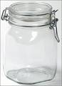

A B C D

E F G H

Cut out the pictures and glue onto the correct jar.

